Welcome to
7th Grade Language Arts
Teacher: Ms. Traub Room: 131 Team: Stars

My goal is your success!
This year in ELA, we will work on:

- Reading Walter Dean Myer’s Bad Boy
- I-Search- an independent research project
  - A deeper exploration into a historical topic
  - Developing research and formal writing skills, as well as introducing MLA Style
- Reading Christopher Cleveland’s screenplay, Glory Road
  - Elements of Drama
  - Literary Devices and Reading Strategies
- Reading Lois Lowry’s novel, The Giver
  - Elements of Science Fiction
  - Critical thinking
  - Evaluation and synthesizing of a text
- Close and Critical Reading of both fiction and non-fiction texts
- Each unit we will be working on both building vocabulary and developing grammar skills

My Expectations:
- Come to class prepared to learn. Bring any material you will need to class, this includes your novel and i-Pad. Being prepared to learn includes being on time, with a writing utensil and an open mind.
- Your i-Pad must be charged. You will be using it almost everyday, for at least part of the class period.
- Respect others, their stuff and their space including me and mine.
- Be willing to try. Challenge yourself!

Grading / Late Work/ Absent Work:
- Work is due on the expected due date. If you leave the classroom at the end of the hour without turning in the assignment in, it is considered late.
- Work turned in on time is graded as:

  - A= 100 - 93
  - A-= 92 - 90
  - B+= 89 - 87
  - B= 86 - 83
  - B-= 82 – 80
  - C+= 79 – 77
  - C= 76 – 73
  - C-= 72 – 70
  - D+= 69 – 67
  - D= 66 – 63
  - D-= 62 - 60
  - F= 59 – 0

- Our team late work policy is If an assignment is not turned in on time, students must have it turned in by the end of the week for half credit.
- For absent work, it is your responsibility to find out what you missed by either checking the “Absent Student” board and binder, talking to a classmate, emailing me, and/ or checking Blackboard. You have the number of days you missed to make up the work.
- Homework / classwork is worth 40% of your over all grade, assessment are worth 60% of your overall grade.

Language Arts Binder:
- A requirement for English class is to keep a binder. There will be additional handouts that supplement your novel and unit of study. Often times these handouts with be directly linked with assignments you will find on Blackboard. You must bring your binder to class everyday.
- Binder Organization: The binder will be organized using the same set up as my class on Blackboard.
  - The binder is organized into appropriate categories with dividers:
    - Vocabulary
    - Grammar
    - Novel
    - Writing / Projects
    - Miscellaneous
Discipline:
- Violation of school or classroom rules and / or offensive, disrespectful behavior will be met with disciplinary action:
  - Step 1: Verbal Warning / Conversation
  - Step 2: Temporary Removal from Classroom w/ “Think Sheet” to reflect
  - Step 3: Lunch / SR detention and phone call home
  - Step 4: After school detention and phone call home
  - Step 5: Referral to the office
    - I reserve the right to bypass any of these steps, depending on the nature of the infraction.
Remind 101:
This school year I will be utilizing the website www.remind101.com as a way of sending out important messages to you. This is a free service; however, if you choose to receive the message via text, then standard messaging rates will apply. I plan on using it to notify you and / or your students of upcoming tests, projects or deadlines. Students will not be able to see my phone number and I will not be able to see their number. Students will not be able to respond to any text that I send. All that enroll will receive my message using the text-messaging component on their phone.

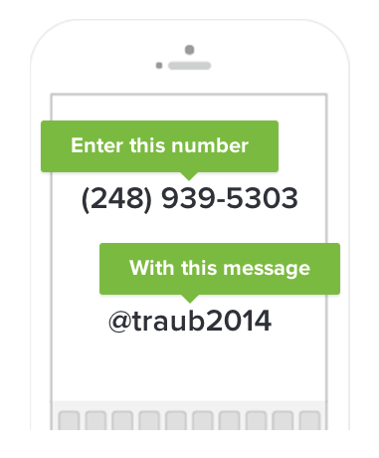
The students will have the opportunity to enroll this week during class. But as a parent, if you want to enroll, the directions are below. You will receive the same text messages as your student.

Other information:
- Grades are updates at least weekly. Please check PoweSchool / Parent Portal often.
- All lesson plans, assignments and resources are posted on Blackboard.

Contact Information:
- The best way to contact is via email: Jacquelyn.Traub@FraserK12.org
- My classroom phone number is 586.439.7431. The best time to call is before or after school. If I don’t answer, leave a voicemail and I’ll return the call the following day.
- Please, don’t hesitate to contact me with questions or concerns at any point.

